**Voice-Based Email & Messaging Assistant**

Hands-Free Email Interaction Using Speech Technologies

**1.** **Problem Statement**

In today’s digital world, email and messaging platforms are essential for communication in personal, academic, and professional domains. However, most existing applications depend heavily on manual typing, screen navigation, and visual interaction. This creates significant challenges for visually impaired users, elderly individuals, and people with physical disabilities. Additionally, busy professionals often find it inconvenient to interact with emails and messages while multitasking.

Although voice assistants exist, there is a lack of a unified, secure, and accessible system that enables users to manage both emails and messages entirely through speech across multiple platforms. The absence of effective hands-free communication solutions limits accessibility, reduces productivity, and restricts inclusive usage of digital communication tools.

Therefore, there is a need to develop a voice-driven assistant that allows users to send, read, reply to, and manage emails and messages using voice commands while ensuring security, privacy, and ease of use.

**2. Introduction:**

Communication through email and messaging platforms plays a crucial role in modern digital life. However, traditional interaction methods such as typing and screen-based navigation are not accessible to all users and are often inconvenient during multitasking. Visually impaired users, elderly individuals, and busy professionals face difficulties in efficiently managing their communication using conventional systems.

With advancements in speech technologies such as Speech-to-Text, Natural Language Understanding, and Text-to-Speech, voice-based interaction has emerged as a practical solution for improving accessibility and usability. Voice-driven systems allow users to interact naturally with applications using spoken language, reducing dependency on physical input devices.

The Voice-Based Email & Messaging Assistant aims to provide a hands-free, secure, and accessible communication platform that enables users to manage emails and messages entirely through voice commands. By integrating speech technologies with secure API-based access to multiple communication platforms, the system enhances accessibility, inclusivity, and productivity.

**3. Objectives**

The primary objective of the Voice-Based Email & Messaging Assistant is to design and develop an accessible, voice-driven communication system that enables users to manage emails and messages hands-free. The specific objectives of the project are as follows:

1. **To enable hands-free communication**  
   Develop a system that allows users to send, read, reply to, and manage emails and messages entirely using voice commands.
2. **To improve accessibility and inclusivity**  
   Provide an effective communication solution for visually impaired users, elderly individuals, and users with physical limitations.
3. **To integrate speech technologies**Implement Speech-to-Text (ASR) for voice command recognition and Text-to-Speech (TTS) for audible responses.
4. **To support multiple communication platforms**Enable interaction with popular email services (such as Gmail and Outlook) and messaging platforms (such as WhatsApp and Telegram) through secure APIs.
5. **To implement intelligent command understanding**Use Natural Language Understanding (NLU) techniques to accurately interpret user intent and execute appropriate actions.
6. **To provide smart message handling features**Include features such as email/message summarization and context-aware reply suggestions to enhance productivity.
7. **To ensure security and privacy**  
   Implement secure authentication mechanisms such as OAuth login and voice or biometric confirmation before sensitive actions.
8. **To design a user-friendly and accessible interface**Provide a simple web or mobile interface with accessibility features such as high-contrast UI and adjustable text sizes.
9. **To deploy a scalable and cloud-ready solution**  
   Containerize and deploy the application on cloud platforms for easy access and scalability**.**

**4.Proposed Solution**

The proposed solution is a Voice-Based Email & Messaging Assistant that enables users to interact with their emails and messages entirely through voice commands. The system is designed to provide hands-free communication while ensuring accessibility, security, and productivity. By integrating speech processing technologies, natural language understanding, and secure API-based communication, the assistant offers a unified platform for managing emails and messages across multiple services.

1. **Overview of the System**

The system allows users to perform essential communication tasks such as sending, reading, replying to, and summarizing emails and messages using spoken commands. It eliminates the need for manual typing and screen-based navigation, making digital communication more inclusive for visually impaired users and more convenient for multitasking professionals.

The assistant operates through a web or mobile interface and provides real-time spoken feedback, ensuring seamless two-way voice interaction.

**2. Speech-Based Interaction**

The core of the proposed solution is voice-driven interaction:

* **Speech-to-Text(STT):**  
  The system captures the user’s voice input through a microphone and converts spoken commands into text using speech recognition technologies.
* **Text-to-Speech(TTS):**  
  Email and message content, system responses, and confirmations are converted into natural-sounding speech, allowing users to receive information audibly. This bidirectional voice interaction ensures a fully hands-free experience.

**3. Intelligent Command Processing**

After converting speech to text, the system applies Natural Language Understanding (NLU) to analyze the user’s intent.

* Identifies commands such as read email, send message, or reply to latest message
* Extracts relevant details like recipient, subject, and message content
* Handles incomplete or ambiguous commands by prompting the user for clarification
* Provides graceful error handling for unrecognized commands

This intelligent processing enables natural and flexible interaction.

**4. Email and Messaging Integration**

The assistant integrates with popular communication platforms using official APIs:

* **Email Services:** Gmail and Outlook APIs are used for sending, reading, and replying to emails securely.
* **Messaging Platforms:** WhatsApp and Telegram are integrated through official or third-party APIs.
* **Unified Inbox:** Emails and messages from different platforms are organized into a single interface for easy navigation.

All interactions strictly follow user-granted permissions to ensure privacy and security.

**5. Smart Message Handling**

To improve user productivity, the proposed solution includes intelligent features:

* **Message Summarization:** Long emails and messages are summarized into concise speech-friendly content using AI-based summarization models.
* **Context-Aware Reply Suggestions:** The system suggests quick replies based on conversation history, which users can approve or modify using voice commands.

These features reduce cognitive load and save time.

**6. Security and Privacy Measures**

Security is a critical component of the proposed solution:

* Secure authentication using OAuth (Google/Microsoft)
* Voice PIN or biometric confirmation before sending messages
* Encrypted storage and handling of access tokens
* Session-based authentication to protect user data

**4.1 Milestone 1: Setup & Authentication**

**4.1.1 Technical Stack Used**

Milestone 1 establishes a secure and reliable foundation for the voice-based email system by integrating authentication, biometric verification, and speech readiness components. The following technology stack was used:

* **Programming Language:** Python
* **Backend Framework:** Flask
* **Biometric Module:** OpenCV (compiled using CMake)
* **Database:** MongoDB Atlas (Cloud-based NoSQL database)
* **Speech Processing:** Whisper / Google Speech-to-Text (STT)
* **Frontend Technologies:** HTML, CSS, JavaScript
* **Build System:** CMake (for compiling the biometric module)

This technology stack was selected to ensure modularity, scalability, and compatibility with future extensions such as Gmail integration, multilingual speech support, and advanced AI-driven features.

**4.1.2 System Design and Execution Flow (Milestone 1)**

Milestone 1 is designed as a **pre-functional security and readiness phase**, during which no email operations are performed. The system follows a sequential and controlled execution flow to ensure authentication correctness and input validation before handling sensitive data.

The high-level execution flow is as follows:

* The user accesses the web application interface.
* The backend services and MongoDB Atlas database connection are initialized.
* Face-based biometric authentication is performed.
* Upon successful authentication, speech hardware and Speech-to-Text readiness are validated.
* All email-related functionalities remain disabled.

This phased execution ensures that authentication and speech input validation are fully verified before proceeding to Gmail integration in subsequent milestones.

**4.1.3 Biometric Authentication Methodology**

To replace traditional password-based authentication, the system employs a **face-based biometric authentication approach**. This method enhances accessibility for visually impaired users and improves security by eliminating password-related vulnerabilities such as phishing and credential reuse.

The biometric subsystem is implemented using OpenCV and compiled with CMake to support modular and efficient execution. Facial data is processed through a computer vision pipeline consisting of face detection, feature extraction, and biometric encoding generation. Rather than storing raw facial images, the system converts facial features into numerical encodings that uniquely represent each user.

During authentication, a live facial sample is captured and compared against the stored encoding using distance-based similarity metrics. Authentication is granted only if the similarity score falls within a predefined threshold, ensuring reliable and accurate identity verification.

**4.1.4 Biometric Data Storage Strategy**

User biometric data is stored securely in **MongoDB Atlas**. The database does not contain raw facial images; instead, it stores biometric encoding references along with minimal metadata associated with the user profile.

This storage strategy provides the following advantages:

* Prevents reconstruction of original facial images
* Enhances privacy and data security
* Supports scalable and cloud-based data management

The document-oriented structure of MongoDB enables easy extension of user records in future milestones without requiring schema redesign.

**4.1.5 Speech Input Readiness and Validation**

Since voice interaction is the primary input mechanism of the system, Milestone 1 validates the speech pipeline independently of email functionality. Microphone access is verified, and basic speech input is captured and processed using the configured Speech-to-Text engine.

At this stage:

* Audio capture reliability is tested
* Speech-to-text transcription accuracy is verified
* Transcribed text is validated for correct backend reception

Speech input is used strictly for validation purposes and does not trigger any functional commands or email operations.

**4.1.6. Security Considerations**

Security is a critical design requirement for the Voice-Based Email & Messaging Assistant, as the system processes sensitive user communication data and authentication credentials. Multiple security mechanisms are implemented to ensure confidentiality, integrity, and controlled access.

The system employs **Google OAuth 2.0 authentication** to enable secure Gmail access. OAuth ensures that users authenticate directly with Google without sharing login credentials with the application. Gmail access strictly follows the **principle of least privilege**, granting only the minimum required permissions.

Access tokens generated through OAuth are handled securely and are never exposed in plain text. Sensitive credentials and tokens are stored in encrypted or protected formats within the backend environment. Face-based biometric authentication further strengthens security by ensuring that only authorized users can access the dashboard and initiate Gmail operations.

Additionally, **session-based authentication mechanisms** protect user interactions across requests and prevent unauthorized reuse of authenticated states. At no point are sensitive user credentials, biometric images, or OAuth secrets stored in plain text, ensuring strong resistance against unauthorized access and credential compromise.

**7. System Workflow**

The system workflow describes the complete sequence of operations performed by the Voice-Based Email & Messaging Assistant, from application initialization to successful user authentication and dashboard availability.

**Step 1: Application Initialization**

When the user opens the web application, the frontend interface and backend services are initialized. Required resources such as database connections, biometric modules, and authentication configurations are loaded. At this stage, the system prepares for user authentication while restricting access to email services.

**Step 2: Face Registration Process**

If the user is accessing the system for the first time, the face registration process is initiated. The system activates the device camera and captures the user’s facial image. The captured frame is validated to check whether a face is detected.

* **If a face is not detected:**
  + The system displays a *“*Face Not Detected*”* message.
  + The user is prompted to retry face capture.
* **If a face is detected successfully:**
  + Facial features are extracted using the biometric processing pipeline.
  + These features are converted into numerical face encodings.
  + The generated encodings are securely stored in the database.
  + Face registration is completed successfully.

This step ensures that a reliable biometric reference is created for future authentication.

**Step 3: Face Login and Verification**

After registration, the user proceeds to the face login phase. A live facial image is captured and processed using the same feature extraction and encoding mechanism.

* **If the face is not recognized:**
  + The system displays a “Face Not Recognized*”* message.
  + The user is prompted to retry face capture.
* **If the face is recognized successfully:**
  + The user is authenticated.
  + Access to the system is granted.

**Step 4: Dashboard Loading**

Upon successful face authentication, the system loads the user dashboard. The dashboard acts as the central interface for accessing application features.

At this stage:

* The user interface becomes fully accessible
* Email operations are enabled only after OAuth authorization
* The system is ready for Gmail integration and voice-based interaction

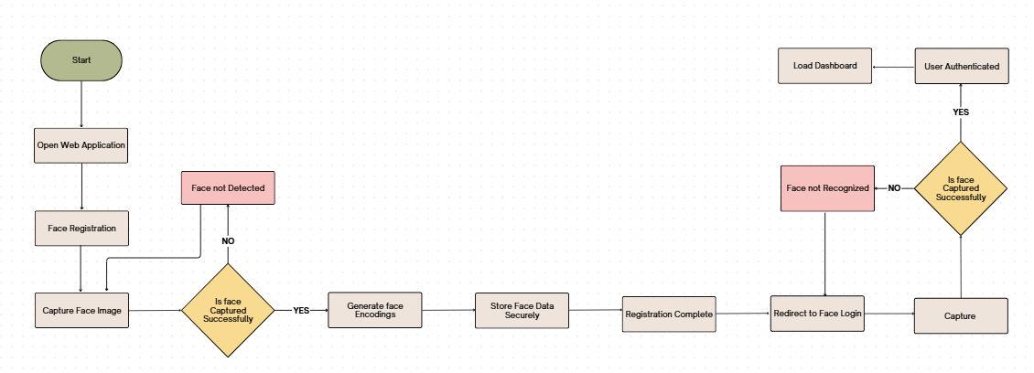

**Milestone-1 Output Screenshots:**

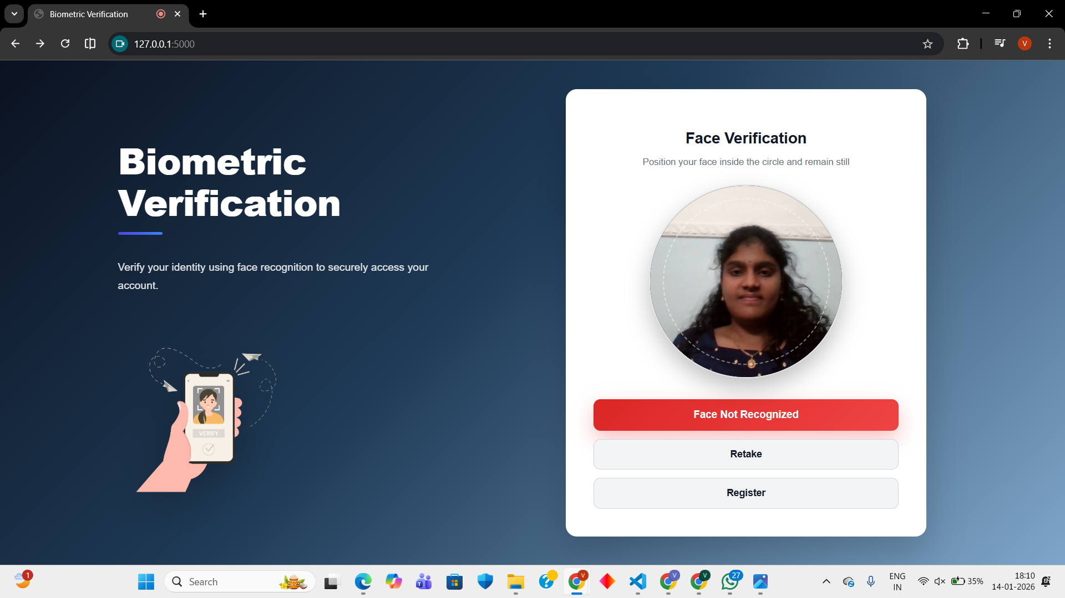

**Fig. 4.1:** Face Not Registered – Error Message Displayed

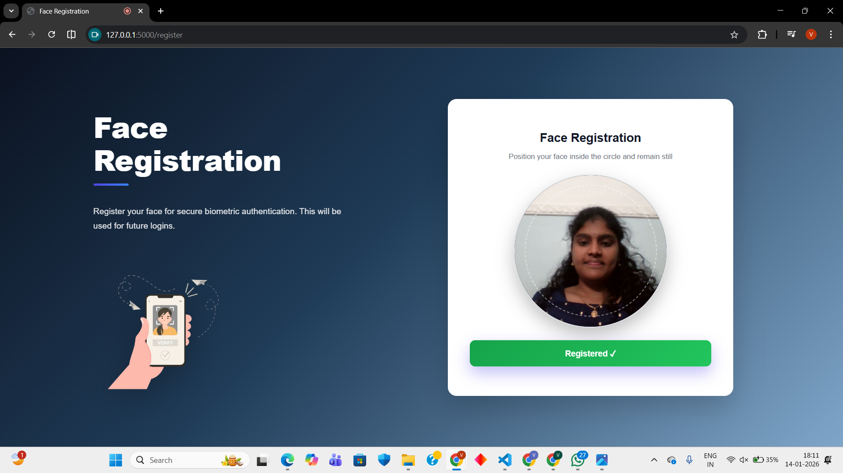

Fig. 4.2: Face Registration Completed Successfully

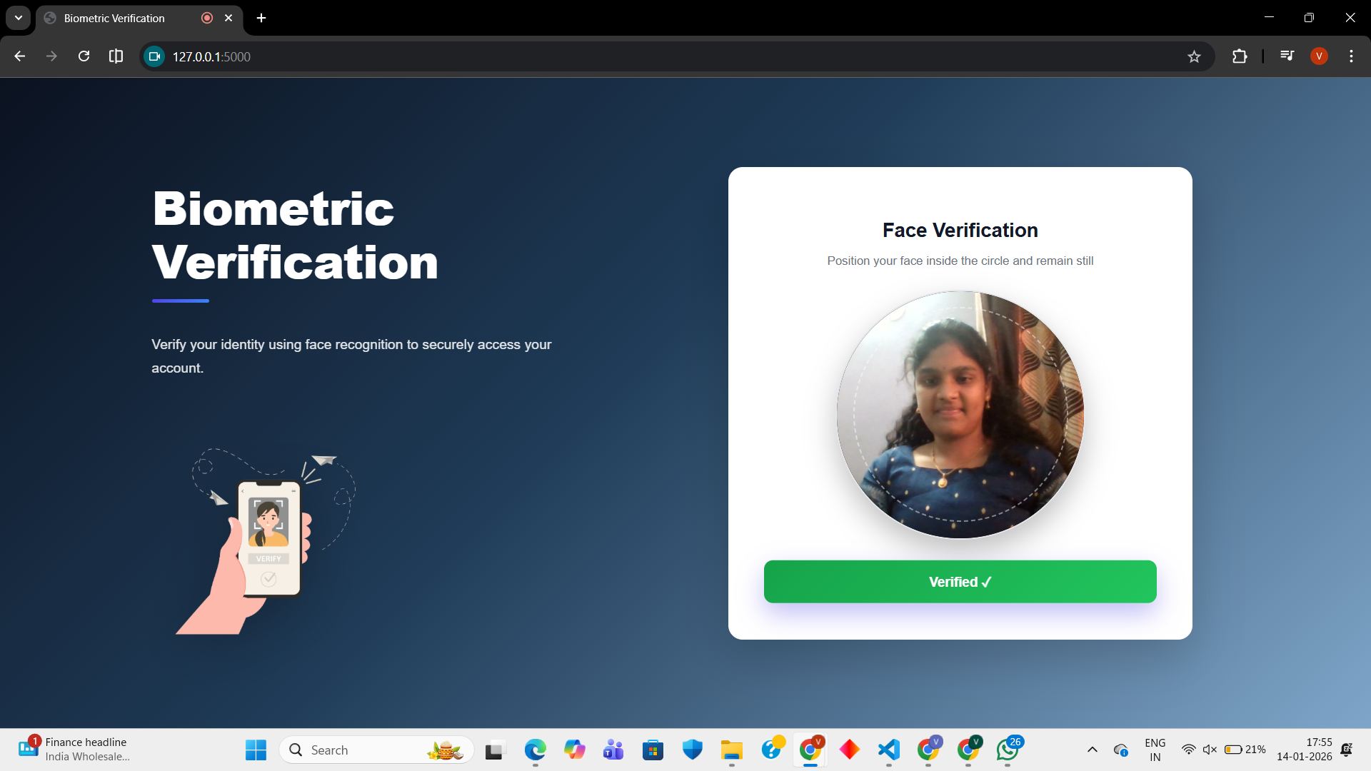

**Fig. 4.3:** Face Verified Successfully During Login

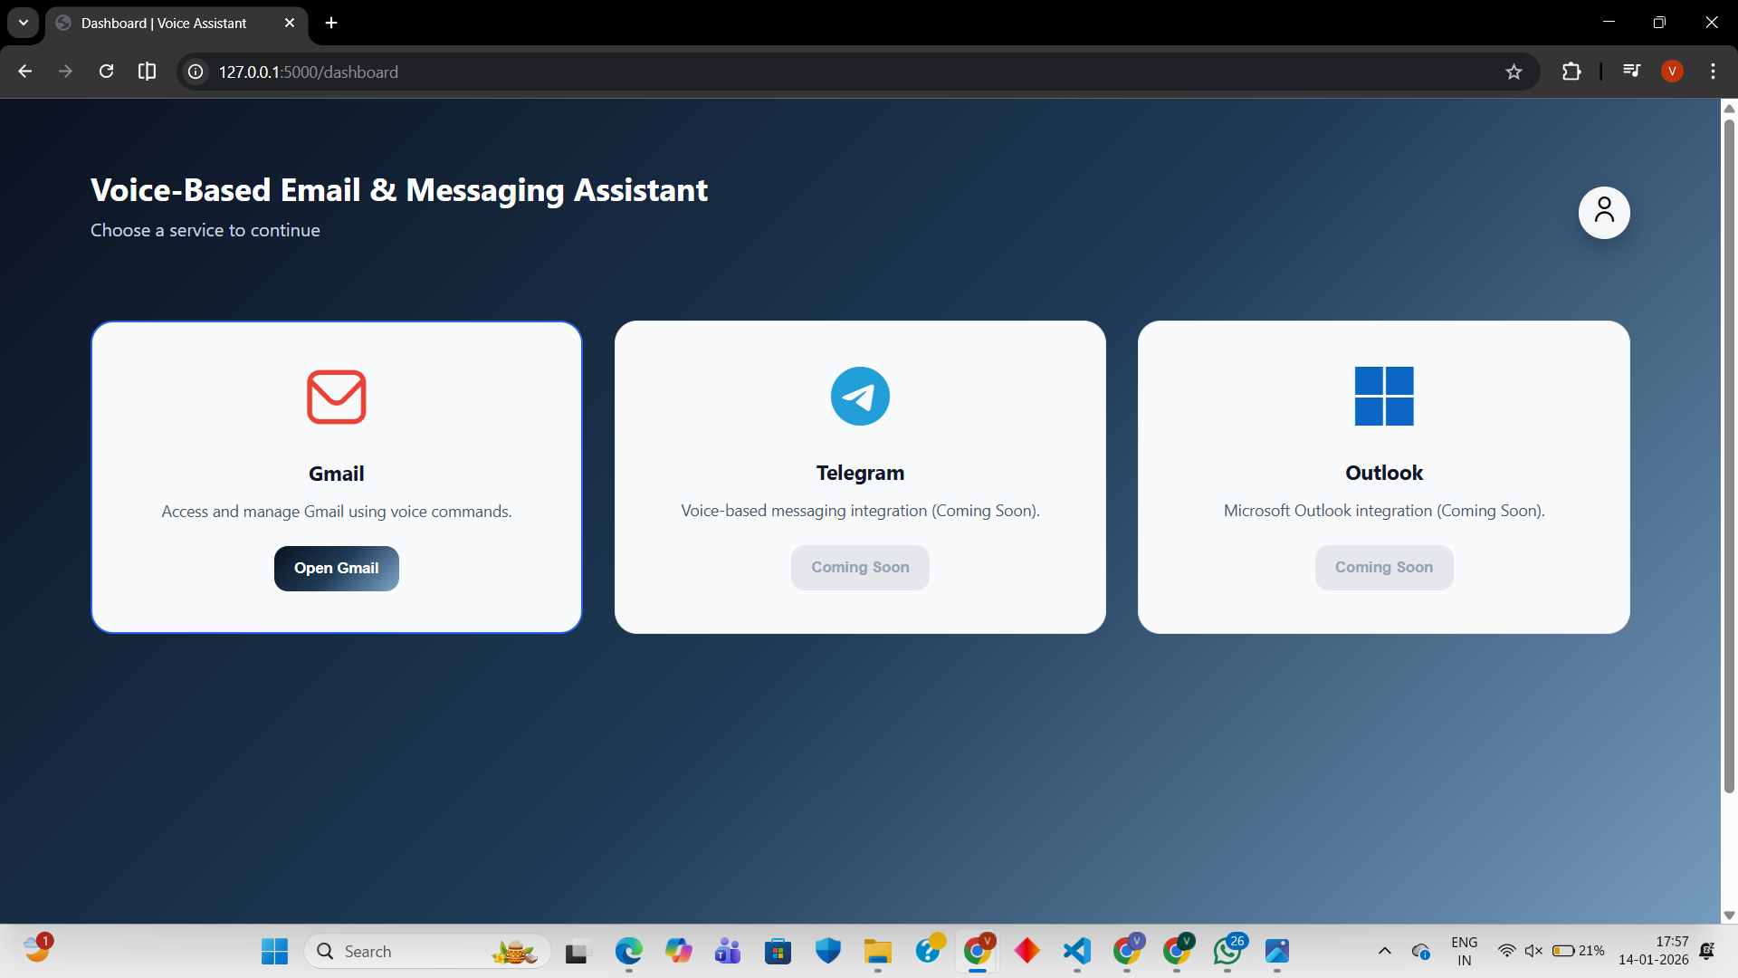

**Fig. 4.4:** Dashboard Loaded After Authentication

**4.1.8 Milestone 1 Outcomes:**

The successful completion of Milestone 1 demonstrates that the system is technically prepared for functional expansion. The following observations were recorded:

* Accurate and reliable face-based biometric authentication
* Secure and privacy-preserving biometric data storage
* Stable microphone access and speech-to-text processing
* Robust backend and MongoDB Atlas connectivity

**4.2 Milestone 2: Core Speech Processing & Gmail Integration**

**4.2.1 Technical Stack Used**

Milestone 2 focuses on enabling **functional, voice-driven Gmail interaction** by integrating speech processing technologies with secure Gmail services. The following technology stack was used:

* **Programming Language:** Python
* **Backend Framework:** Flask
* **Speech-to-Text (STT):** Web Speech API
* **Text-to-Speech (TTS):** Web Speech API
* **Email Integration:** Gmail API
* **Authentication & Authorization:** Google OAuth 2.0
* **Database:** MongoDB Atlas (for OAuth token storage)
* **Frontend Technologies:** HTML, CSS, JavaScript

This stack ensures secure communication with Gmail services while supporting real-time speech interaction and scalability for future extensions.

**4.2.2 System Design and Execution Flow**

Milestone 2 builds upon the secure and authenticated environment established in Milestone 1. Once the user is authenticated using face-based biometrics, the system enables Gmail-related functionalities through OAuth authorization and voice-based command execution.

The high-level execution flow is as follows:

* The authenticated user accesses the dashboard.
* Gmail module is selected.
* OAuth authorization is verified.
* Gmail inbox is accessed using Gmail API.
* User interacts with Gmail using voice commands.
* System responds using Text-to-Speech output.

This controlled flow ensures that Gmail operations are executed only after successful authentication and authorization.

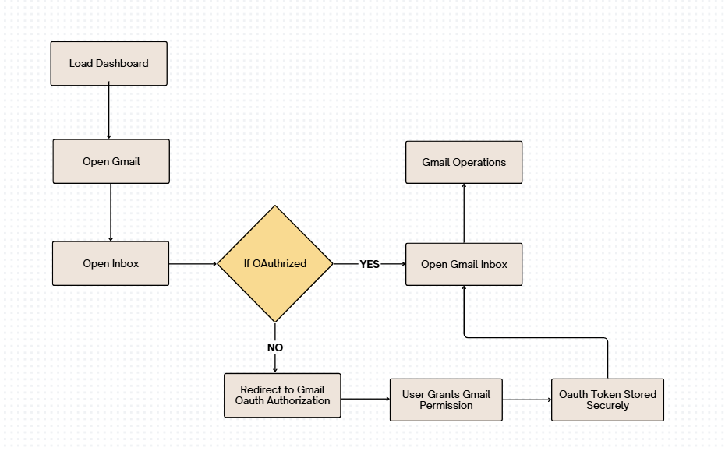

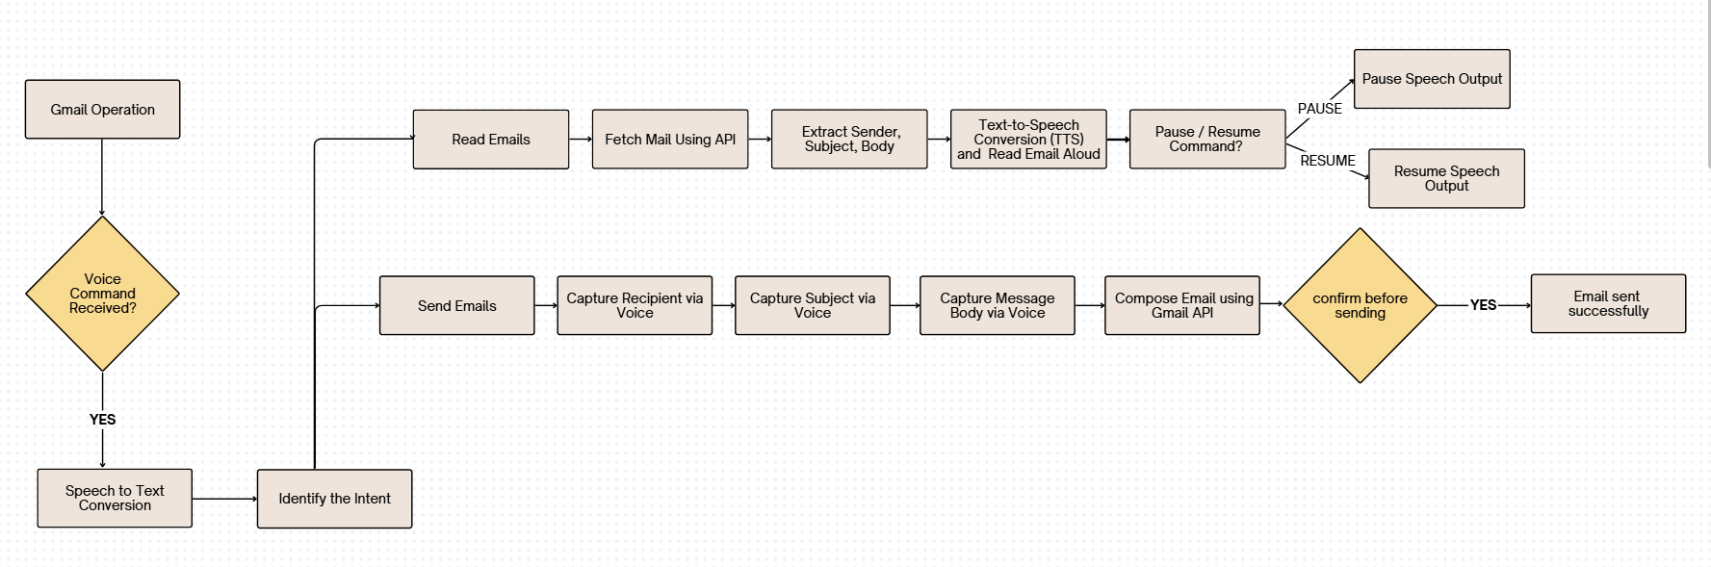

**4.2.3 Gmail OAuth 2.0 Authorization**

To ensure secure access to Gmail services, Milestone 2 implements Google OAuth 2.0 authorization. OAuth allows users to grant permission to the application without sharing their Gmail credentials.

The OAuth workflow includes:

* Redirecting the user to Google’s consent screen.
* Requesting minimal required permissions (read, send).
* Receiving an access token upon user approval.
* Securely storing the token for subsequent API calls.

This mechanism follows the principle of least privilege and ensures compliance with Google security standards.

**4.2.4 Speech-to-Text (STT) Processing**

Speech-to-Text forms the primary input mechanism in Milestone 2. The system continuously listens for user voice commands and converts spoken audio into textual form.

The STT pipeline performs:

* Audio capture through the microphone.
* Noise handling and preprocessing.
* Conversion of speech into text.
* Transmission of transcribed text to the backend.

The recognized text serves as the basis for intent identification and Gmail operation execution.

**4.2.5 Intent Identification and Command Processing**

Once speech is converted into text, the backend analyzes the text to identify the user’s intent. A rule-based intent classification approach is used to ensure reliability and predictability.

Supported intents include:

* Reading emails
* Sending emails
* Pausing speech output
* Resuming speech output

After intent identification, the corresponding Gmail operation is triggered. Invalid or unrecognized commands result in a retry prompt, ensuring robust interaction.

**4.2.6 Gmail API Operations**

Based on the identified intent, the system interacts with Gmail services using the Gmail API.

**Email Reading Operation**

* Fetches emails from the inbox using Gmail API.
* Extracts sender, subject, and message body.
* Converts extracted content into speech using TTS.
* Reads the email aloud to the user.

**Email Sending Operation**

* Captures recipient address via voice.
* Captures subject and message body via voice.
* Constructs the email using Gmail API.
* Requests user confirmation before sending.
* Sends the email upon confirmation.

This approach ensures safe and accurate email management through voice commands.

**4.2.7 Text-to-Speech (TTS) and Playback Control**

The Text-to-Speech module converts textual email content into audible speech output. To enhance user experience, pause and resume functionality is implemented.

During email reading:

* The system listens for “Pause” and “Resume” commands.
* Speech output is paused immediately upon request.
* Speech resumes from the last position without repetition.

This feature significantly improves usability, especially for long emails.

**4.2.8 Security Controls in Milestone 2**

Security remains a priority in Milestone 2. The system enforces:

* OAuth-based Gmail access
* Secure token handling
* Permission-based API usage
* Explicit user confirmation before sending emails

These controls ensure that Gmail operations are executed safely and only with user consent.

**4.2.9 Results and Observations**

The successful execution of Milestone 2 demonstrates the system’s ability to perform real-time, voice-driven Gmail operations.

Observed outcomes include:

* Accurate recognition of voice commands
* Successful Gmail OAuth authorization
* Reliable email reading using TTS
* Safe email composition and sending
* Effective pause and resume speech control

**Output Screenshots:**

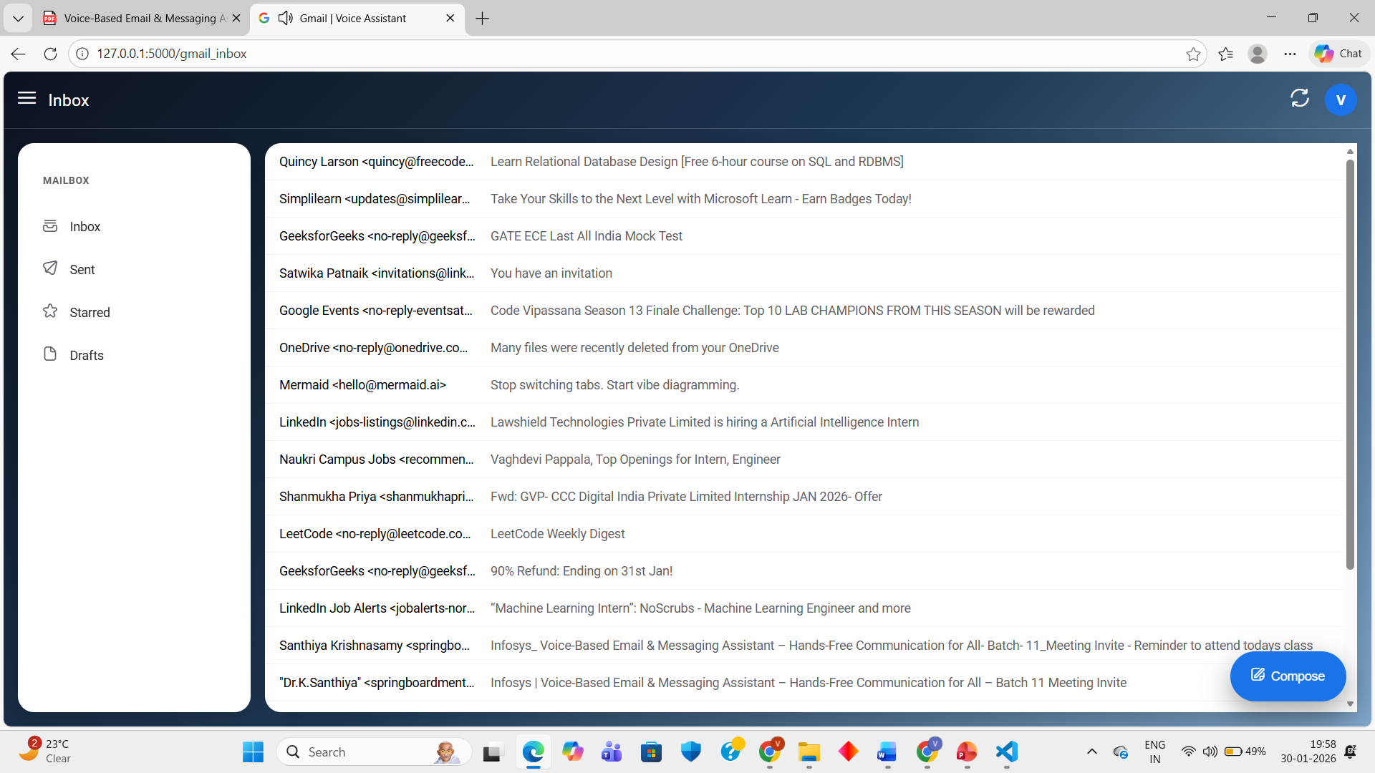

Fig -1 : Gmail Inbox

.

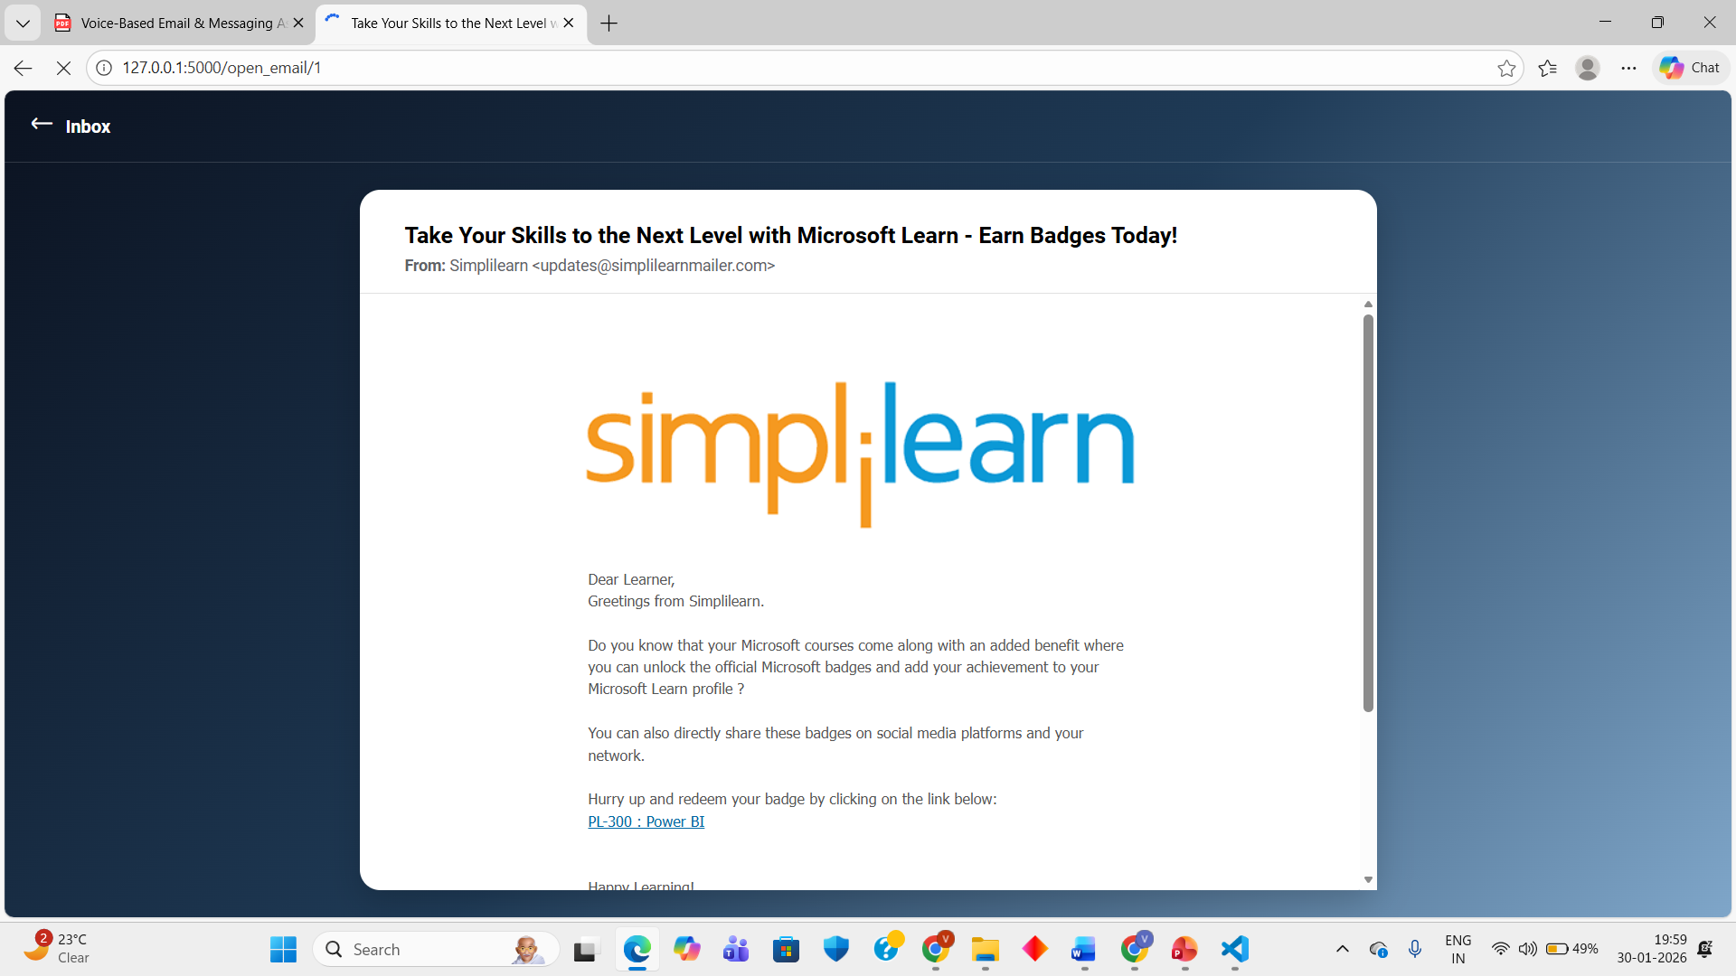

Fig -2 : Mail opened

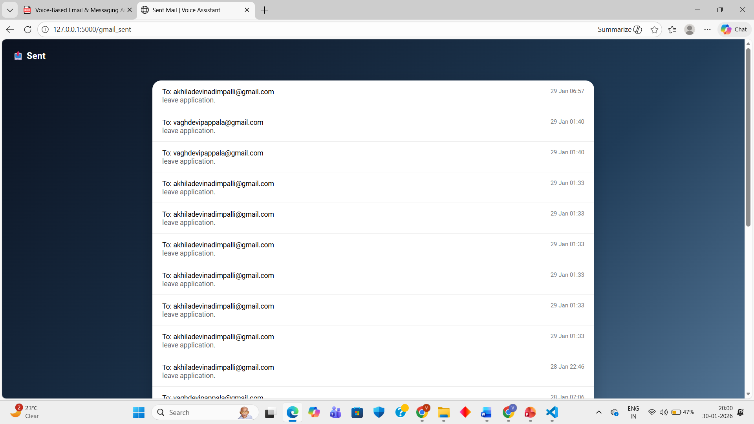

Fig-3 : Sent mails

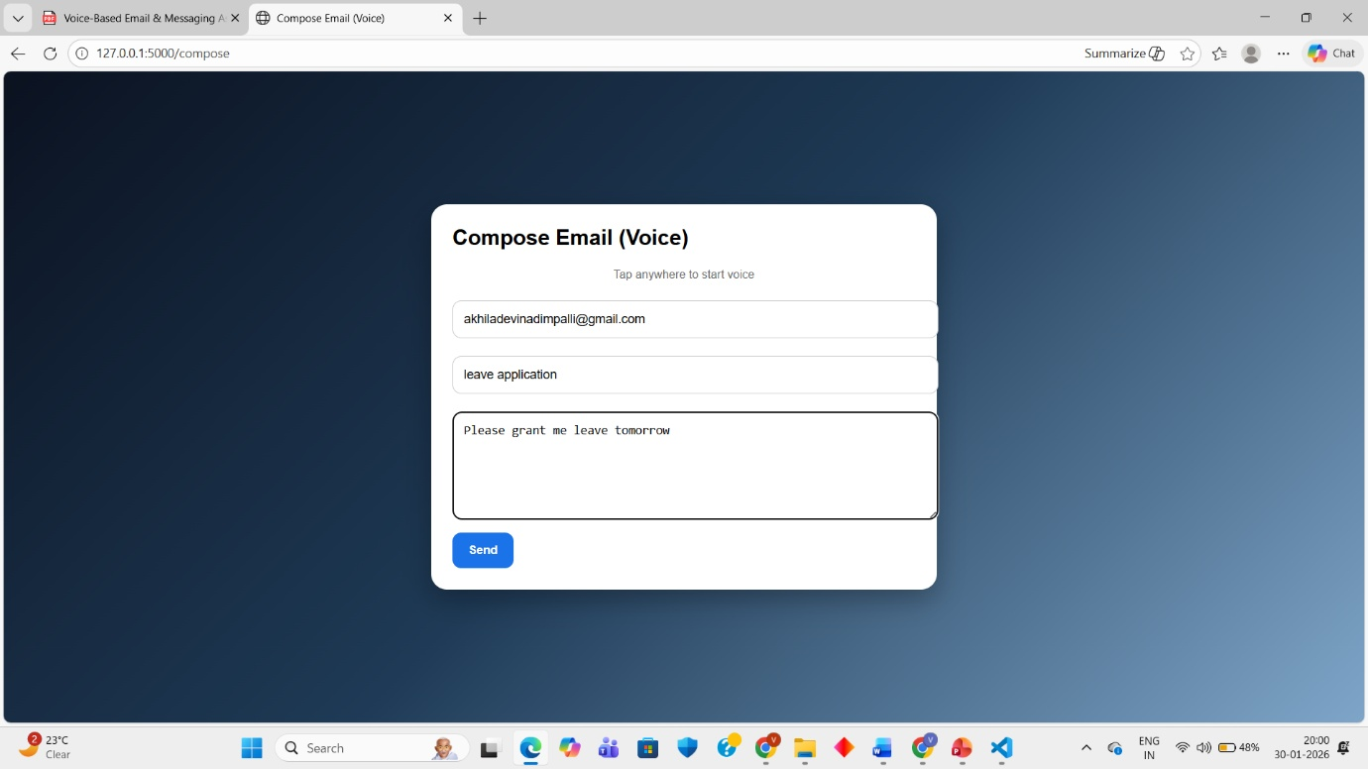

Fig-4 : Composing Emails

**4.2.10 Milestone 2 Outcome**

Milestone 2 successfully transforms the system into a functional voice-controlled Gmail assistant. The integration of Speech-to-Text, Gmail API, and Text-to-Speech enables hands-free email reading and sending with real-time playback control. This milestone delivers a working Minimum Viable Product (MVP) and provides a strong foundation for future enhancements such as summarization, multilingual support, and messaging platform integration